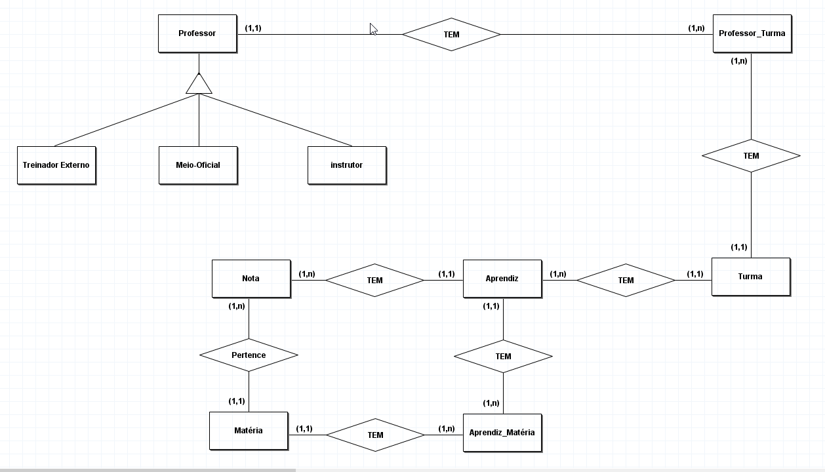

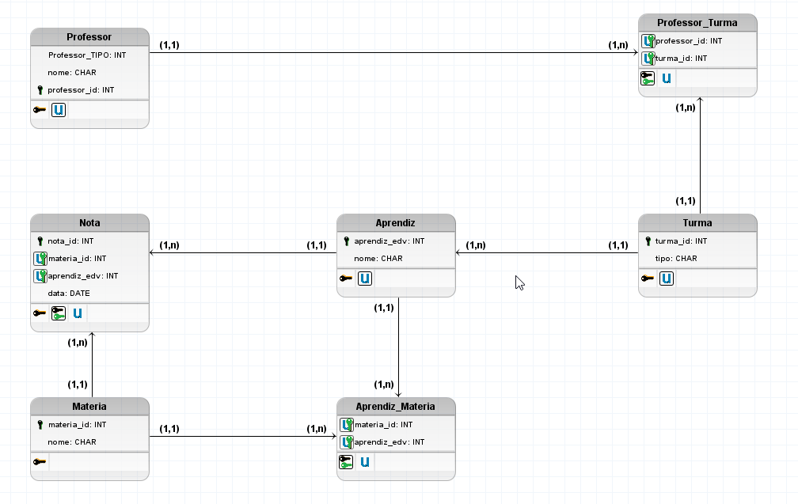

create table Departamentos(

dep_id INT PRIMARY KEY,

dep_nome VARCHAR (20),

dep_local int

)

create table Funcionarios(

edv INT PRIMARY KEY,

nome VARCHAR (15),

lider VARCHAR (15),

data_contratacao date,

salario int,

dep_id int,

FOREIGN KEY (dep_id) REFERENCES Departamentos(dep_id)

)

create table Grade_salarial(

grade INT PRIMARY KEY,

sal_min int,

sal_max int

)

INSERT INTO Departamentos (dep_id, dep_nome, dep_local)

VALUES

(1, 'REMAN', 104),

(2, 'ICO', 101),

(3, 'ETS', 401),

(4, 'FCM', 303),

(5, 'INOVE', 303);

INSERT INTO Grade_salarial (grade, sal_min, sal_max)

VALUES

(1, 1500, 4000),

(2, 4001, 9000),

(3, 9001, 22000),

(4, 22001, 50000);

INSERT INTO Funcionarios (edv, nome, lider, data_contratacao, salario, dep_id)

VALUES

(92890148,'Edna Carvalho','Andrea','1990-02-24',19000,1),

(92790062,'João Manfredo','Andrea','2001-09-26',12500,1),

(91004090,'Débora Junior','Andrea','1999-03-02',15600,1),

(94566222,'Carla Rodrigues','Andrea','1990-10-04',20000,1),

(96334100,'Maciel Oliveira','Andrea','1995-12-06',16500,1),

(97885245,'Guilherme Gui.','Marcos','2010-05-13',9000,2),

(92894706,'Jessica Lima','Marcos','2015-08-14',25678,2),

(91450032,'Isabella M.','Marcos','1993-01-22',10900,2),

(94661932,'Carlo Daniel','Lucio','1990-01-31',13750,2),

(95780634,'Maria Santana','Lucio','2015-09-05',8000,2),

(97881945,'Dominic F.','Pietra','2020-02-09',2000,3),

(98490620,'Daniela Silva','Pietra','2020-02-09',1500,3),

(96854299,'Felipe Augusto','Pietra','2020-02-09',1600,3),

(97805503,'Natalia Reis','Pietra','2019-06-14',2200,3),

(90103456,'Thiago Dias','Pietra','2018-08-24',2800,3),

(98462157,'Lorena Ray','Pietra','2017-02-25',1900,3),

(95482340,'Natanael Brasil','Pietra','2020-06-03',3500,3),

(96314782,'Ana Mass','Captu','1997-02-19',3600,4),

(97854318,'Otávio Luis','Captu','2017-05-19',9200,4),

(94862122,'Luisa Otávia','Captu','2002-11-11',10500,4),

(97864320,'Lucas Moura','Captu','1990-08-29',6600,4),

(96315782,'Fernanda L.','Captu','1999-12-17',2900,4),

(97546210,'Caroline Adeus','Captu','2018-02-19',4555,4),

(94621573,'Marco Valastro','Captu','2003-03-30',7000,4),

(96548432,'Valdemir C.','Jonas','2020-03-15',1200,5),

(97511020,'Eduarda Souza','Jonas','2011-08-14',1100,5),

(96410654,'Allan Jonas','Felipe','2008-06-17',3200,5),

(95645012,'Diana Jones','Felipe','2002-09-24',2050,5),

(94746054,'Mario Bros','Felipe','1990-01-18',25600,5),

(92085478,'Aline Franco','Jonas','1996-05-05',3700,5);

select Funcionarios.nome, Departamentos.dep_nome as 'Setor' from Funcionarios inner join Departamentos on Funcionarios.dep_id=Departamentos.dep_id where Funcionarios.nome like 'd%';

select Funcionarios.nome, Funcionarios.salario as 'Maior salario' from Funcionarios inner join Departamentos on Funcionarios.dep_id=Departamentos.dep_id where Funcionarios.nome like 'd%' and funcionarios.salario=(select Max(salario) from funcionarios where nome like 'd%');

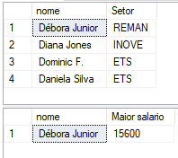

select Funcionarios.nome, Departamentos.dep_nome as 'Departamento', Departamentos.dep_local as 'Local de Trabalho' from Funcionarios inner join Departamentos on Funcionarios.dep_id=Departamentos.dep_id;

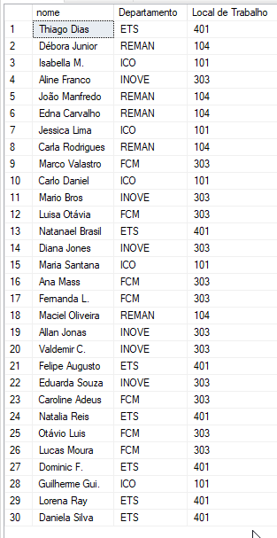

UPDATE Funcionarios

SET salario+=((select sum(salario) from Funcionarios where lider='jonas')/(select count(nome) from Funcionarios where lider!='jonas'))

WHERE lider!='jonas';

DELETE FROM Funcionarios where lider='jonas';

select * from funcionarios order by lider asc;

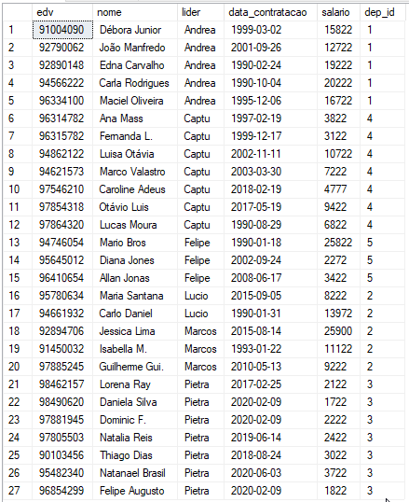

select nome, edv, lider, (select grade from grade_salarial where ((select salario from funcionarios where data_contratacao=(select min(data_contratacao) from funcionarios))>grade_salarial.sal_min and (select salario from funcionarios where data_contratacao=(select min(data_contratacao) from funcionarios))<grade_salarial.sal_max)) as 'Grade' from Funcionarios where data_contratacao=(select min(data_contratacao) from funcionarios);



select count(nome) as 'Salarios > 4000', departamentos.dep_nome as 'Setor' from Funcionarios inner join Departamentos on Funcionarios.dep_id=Departamentos.dep_id where salario>4000 group by departamentos.dep_nome;

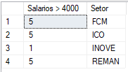

UPDATE Funcionarios

SET lider='Marcos'

WHERE lider='Lucio';

select nome, edv from Funcionarios where data_contratacao>='2015-01-01' and lider='marcos';

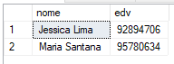

select Departamentos.dep_nome as 'Setor', avg(funcionarios.salario) as 'Media Salarial', max(funcionarios.salario) as 'Maior Salario', min(funcionarios.salario) as 'Menor Salario' from Funcionarios inner join Departamentos on Funcionarios.dep_id=Departamentos.dep_id group by departamentos.dep_nome;

